國立臺灣大學電機資訊學院資訊工程學系
碩士論文
Department of Computer Science and Information Engineering
College of Electrical Engineering and Computer Science
National Taiwan University
Master Thesis

以GCRR模型和Ritchken模型評價障礙選擇權之
實做與收斂比較
Convergence Comparison of GCRR and Ritchken Models

陳宜廷
Yi-Ting Chen

指導教授：呂育道 博士
Advisor: Yuh-Dauh Lyuu, Ph.D.

中華民國96年7月
July 2007

國立臺灣大學碩士學位論文
口試委員會審定書
以GCRR模型和Ritchken模型評價障礙選擇權之
實做與收斂比較
Quasi-Monte Carlo Methods for Option Pricing

本論文係陳宜廷 君（R92723065）在國立臺灣大學資訊工程學所完成之碩士學位論文，於民國96年7月11日承下列考試委員審查通過及口試及格，特此證明

口試委員：
（簽名）
（指導教授）

系主任、所長 （簽名）

Contents

- Introduction
  - Introduction
  - Organization of This Thesis
- Background
2.1 Monte Carlo Simulation
2.2 Estimating the Greeks Using Simulation
2.2 Antithetic Variates

3 Quasi-Monte Carlo Methods
3.1 Low Discrepancy Sequences
3.1.1 Halton Sequences
3.1.2 Faure Sequences
3.1.3 Sobol Sequences
3.2 Pseudo Random Uniform Sequences
3.2.1 rand()
3.2.2 The Mersenne Twister
3.3 Normal Inversion Methods

4 Numerical Results
4.1 Evaluating Vanilla Call Options
4.2 Evaluating Rainbow Options
4.3 Evaluating Asian Options

5 Conclusions

Bibliography

Appendix

ABSTRACT

Monte Carlo simulation has proved to be a valuable tool for estimating security prices for which closed form solutions do not exist. This thesis evaluate the Quasi-Monte Carlo method that has attractive properties for the numerical valuation of derivatives and examines the use of Monte Carlo simulation with low discrepancy sequences for valuing derivatives versus the traditional Monte Carlo method using pseudo-random sequences.
The relative performance of the methods is evaluated based on three financial securities pricing problems: European call options, rainbow options, and Asian options.

Chapter 1
Introduction
  - Introduction

With the growth of financial market, lots of exotic options are trade in the OTC market to meet clients’ needs. However, few of the exotic options have analytical solution. Hence, numerical methods come to play an important role in modern finance. One approach is finite difference method. Another popular technique is use lattice or tree model. Monte Carlo methods are often used when these methods are difficult to implement. Since Boyle proposed Monte Carlo (MC) simulation for estimating security prices, simulation has proved to be a powerful and flexible tool for many types of derivatives calculations. Even so, there are some deficiencies with this method. First the error bound is probabilistic, not a concrete guarantee about the accuracy. Another fatal drawback of the Monte Carlo method is that many simulation paths may be required to obtain a high level of accuracy as the convergence rate is proportional to , where N is the number of simulations.
The Quasi-Monte Carlo (QMC) integration addresses the above-mentioned problems. Quasi-Monte Carlo integration is a method of numerical integration that operates in the same way as Monte Carlo integration. However, it uses sequences of quasi-random numbers which have a more uniform behavior for computing the integral.
In this thesis we use both pseudo-random number generators and low-discrepancy sequences in Monte Carlo simulation to value various derivative contracts, including vanilla call options, rainbow options, and Asian options and discuss the problems that may be encountered in implementing these sequences. We also compare their performance relative to pseudo-random sequences.
1.2 Organization of This Thesis
There are five chapters in this thesis. In chapter 1, a brief introduction is presented. In Chapter 2, we introduce some basic concepts of Monte Carlo method. In chapter 3, we introduce the Quasi-Monte Carlo method and the random number generators. In chapter 4, we show the numerical results. Finally, conclusions are in Chapter 5.

Chapter 2
Background
2.1 Monte Carlo Simulation
In a risk-neutral environment, the value of the derivative security is the discounted value of its expected terminal date cash flow:
.
Monte Carlo simulation approximates the expectation of the derivative’s terminal cash flows with a simple arithmetic average of the cash flows taken over a finite number of simulated price paths:
.
For a large sample of simulated price paths, the mean of the sample will closely approximate the derivative’s true price. The rate of convergence is . Unfortunately, the use of pseudo-random numbers yields an error bound which is probabilistic and the rate of convergence is slow. Therefore, high accuracy requirements may lead to long computation times.
To simulate a price path of the underlying asset, we assume the asset follows a geometric Brownian motion process:
.
After a large number of simulation paths, we compute a simple arithmetic average of the resulting terminal values. This gives us the expected terminal value of the derivative, which we discount to the present at the risk-free rate to obtain the derivative’s current price.
2.2 Estimating the Greeks Using Simulation
Most of the discussion in this thesis centers on the use of Monte Carlo for pricing securities. In practice, the evaluation of price sensitivities is often as important as the evaluation of the prices. For hedging purposes, when managing a lot of derivatives it is also important to know the risk exposure. Whereas prices for some derivatives can be observed in the market, their sensitivities to parameter changes typically cannot and must therefore be computed. The sensitivities are the partial derivatives of the derivative price with respect to parameters of interest. Sensitivity measures of derivatives for which closed-form formulas do not exist have to be computed numerically.
The two important Greeks estimated in this thesis are Delta and Gamma.
Delta is defined as
,
where is a small change in the stock price and is the resulting change in the derivative’s price.
Gamma is defined as
.
Gamma measures how sensitive delta is to changes in the price of the underlying asset.
We use finite differences to approximate the real differentials. Delta can be estimated through
,
and gamma can be estimated through
by choosing a small enough .
Blandford, Butterworth and Good discuss the estimation of price sensitivities and point out that it is important to use the same sequence of random numbers when calculating the Greeks. The method is usually referred to as common random numbers.
2.3 Antithetic Variates
The antithetic-variate method is one of the most widely used variance-reduction techniques.Let
be generated from a random sample
of independent standard normal numbers. Now generate a second variable
from the random sample
.
which is also a standard normal distribution.Then
is also an unbiased estimator with
.
If < then <.
As uses twice as many replications as , we must account for differences in computational requirements. Thus, for antithetics to increase efficiency, we require
,
which means .

Chapter 3
Quasi-Monte Carlo Methods
Quasi-Monte Carlo simulation is like the traditional Monte Carlo simulation except that it uses quasi-random sequences instead of pseudo-random number sequences. The quasi-random sequences are also called low-discrepancy sequences (see Appendix A).
In reality, the low-discrepancy sequences are totally deterministic, so the name “quasi-random” can be misleading.
Quasi-Monte Carlo simulation generates a deterministic upper bound to the error that is of the order of , where s is the number of dimensions of the problem.
This chapter will introduce three kinds of low discrepancy sequences and two kinds of pseudo random number generators for generating uniform distribution sequences.
3.1 Low Discrepancy Sequences
3.1.1 Halton Sequences
The Halton sequence uses one different prime base for each dimension. The first dimension uses base 2, the second dimension base 3, the third dimension base 5, and so on. Higher base means longer cycle and more computational time. The sequence corresponding to the prime m has cycles of length m in which numbers increase monotonically. This characteristic makes the initial terms of two sequences highly correlated (see Appendix B). Therefore, the first 10 to 200 Halton points are usually discarded.

To generate Halton sequences, we follow the two-step procedure.
Step1:
Each integer I is expanded in a base m, where m is any prime number greater than or equal to 2. That is, each integer is converted to its representation in the base m number system
Step2:
The base m number is transformed into a number in the interval [0,1 ) by reflection about the decimal point.

3.1.2 Faure Sequences
The Faure sequence is a permutation of the Halton sequence. Unlike the Halton sequence, it uses the same base for each dimension. The base m is the smallest prime number that is greater than or equal to the number of dimensions in the problem and not smaller than 2. Denote the kth point by
The first component is the one-dimensional Halton sequence
.
To generate Faure sequences, follow the following procedure.
If
then
where
.
Unlike the Halton sequence, the Faure sequence no longer lies in cycles of increasing terms with the exception of the first dimension. Because the Faure sequence is essentially a reordering of the Halton sequence, it suffers from the same start-up maladies. For low values of k and high dimensions, the Faure points tend to cluster about zero and cause higher correlation between neighboring components of the points (see Appendix B). Additionally, the points become repetitive at low values of n. To minimize these effects, it is suggested that we discard the first numbers.
3.1.3 Sobol Sequences
The Sobol sequence, like the Faure sequence, is a reordering of the Halton sequence. Unlike the two other sequences, the multidimensional Sobol sequence eliminates the problems caused by large prime numbers by using the same base m=2. So, there is some computational time advantage due the shorter cycle length. This thesis uses the faster algorithm of Antonov and Saleev.
The construction of a multidimensional Sobol sequence follows a three-step procedure. Because the steps are identical for each dimension, we illustrate the procedure for one dimension.
Step1:
Generate a set of odd integers m_{i}, for
, that satisfy the condition:
,
where N is the number number of price paths, and is the smallest integer larger than . is the maximum number of digits in the expansion of N in base 2.
To generate the Sobol sequence, a primitive polynomial is needed for each dimension.
Let the polynomial be
.
Our interest in the primitive polynomial is only in its coefficients.
For each polynomial a set of q initial odd integers m_{i} is also required. Then, we generate the set of m_{i} for all i>q using the coefficients of the primitive polynomial and the recursive relationship:
.
Step2:
Convert the odd integer m_{i} into a binary fraction in the base 2 number system to gain the direction number v_{i}.
in base 2.
Step3:
Use the Antonov and Saleev recursive algorithm to calculate the n^{th} Sobol number :
,
where , is the c^{th} direction number, and c is the rightmost zero-bit in the base 2 expansion of .
3.2 Pseudo Random Uniform Sequences
To evaluate quasi-random sequences, we need pseudo-random number generators. Pseudo-random sequences look like random numbers because they look unpredictable. However, pseudo-random numbers are generated with deterministic algorithms. The rand() function and the Mersenne Twister are two commonly used pseudo-random number generators. Table 3 illustrates the statistical properties of quasi-random sequences and pseudo-random sequences.
3.2.1 rand()
The most commonly used random generator is the rand() function. In this thesis we use the rand() function in Borland C++ 6.0 to produce random integers I in [0,M] and then divide them by M to yield uniform random variables.
3.2.2 The Mersenne Twister
The Mersenne twister (MT) algorithm was developed in 1997 by Makoto Matsumoto and Takuji Nishimura, which provides the fast generation of high quality random numbers. The algorithm provides a high quality distribution and its output is free of long-term correlations.

Table 3.1
Comparison(n=1000)for Uniform Dist. U[0,1]
 | Theoretical | Rand() | MT | Halton | Faure | Sobol
 |  |  |  | dim=1 | dim=1 (base3) | dim=1
Mean | 0.50000 | 0.49900 | 0.49380 | 0.50011 | 0.49892 | 0.50030
variance | 0.08333 | 0.08410 | 0.08348 | 0.08322 | 0.08333 | 0.08335
Skew | 0.00000 | 0.05444 | (0.02996) | (0.00123) | (0.00001) | 0.00168
Kurtosis | (1.20000) | (1.19365) | (1.24380) | (1.19722) | (1.19822) | (1.19951)
Max | 1.00000 | 0.99918 | 0.99508 | 0.99902 | 0.99863 | 0.99902
Min | 0.00000 | 0.00021 | 0.00005 | 0.00049 | 0.00046 | 0.00195
As we can notice from Table 3.1, in general, the quasi-random sequence outperforms the pseudo-random sequence and presents better uniformity.
3.3 Normal Inversion Methods
Algorithms are available to transform a uniform distribution into any other distribution. The most important distribution for financial applications is the standard normal distribution. In this section, we compare three normal inversion methods; the Acklam inversion (PJA), the Moro Inversion, and the NORMINV function of Excel 2000.
The traditional inversion algorithm given by Beasley and Springer is not good for the tails of the normal distribution. Moro improves the algorithm by using the Beasley and Springer algorithm for the central part of the normal distribution and the truncated Chebyshev series to approximate for the tails of the distribution for higher accuracy. Acklam uses similar idea but different coefficients in rational approximations to generate the inversion algorithm. Both inversion methods can produce satisfactory accuracy.
The following table shows that Moro's inversion and PJA’s inversion are at least exact for the precision of 5 decimal digits. But the NORMINV function of Excel is not accurate for the tails of the normal distribution. So the numerical results in this thesis use Moro's inversion and PJA’s inversion to produce the normal distribution.

Tabe3.2
Comparison of Normal Inversion Functions
u | Normal[0,1] | Moro | PJA | Excel
0.99999 | 4.26489 | 4.26489 | 4.26489 | 4.26504
0.99900 | 3.09232 | 3.09023 | 3.09023 | 3.09025
0.90000 | 1.28155 | 1.28155 | 1.28155 | 1.28155
0.49990 | (0.00025) | (0.00025) | (0.00025) | (0.00025)
0.10000 | (1.28155) | (1.28155) | (1.28155) | (1.28155)
0.01000 | (2.32635) | (2.32635) | (2.32635) | (2.32635)
0.00100 | (3.09023) | (3.09023) | (3.09023) | (3.09025)
0.00010 | (3.71902) | (3.71902) | (3.71902) | (3.71909)
0.00001 | (4.26489) | (4.26489) | (4.26489) | (4.26504)

There are other algorithms for translating the uniform normal into a normal distribution. The most common of these is the polar method. The polar method transforms two uniform random variables to two standardized normal random variables at the same time. But, for quasi random number there are repots that say that it is not satisfactory to use polar method because it alters the order of the sequence and destroys the uniformity.
In this thesis, we incorporate the polar method uses the rand() function to generate standardized normal random variables.

Chapter 4
Numerical Results
We test the efficiency of Quasi-Monte Carlo and standard Monte Carlo by using them here to price three kinds of options: vanilla call options, rainbow options, and Asian options.
4.1 Evaluation with Vanilla Call Options
A vanilla call option provides the holder of the option with the right to buy the underlying asset by a certain date for a given price known as the strike price. The date in the contract is known as the maturity. The payoff function is the following:
X=max(S_{T}-K,0),
where S_{T} is the asset price at the maturity, and K is the strike price.
Parameters: S₀=100,K=100, T=1, r=5%, q=2%, and σ=0.1

As vanilla call option follows a path-independent process, we only need to simulate the terminal asset price. But we still simulate the entire price path using a discrete approximation to explore the impact of increasing dimensionality on the low-discrepancy sequences in two cases: 1) 12 time intervals (Table 4.1.1) and 2) 100 time intervals (Table 4.1.2) and implement antithetic variance reduction (Table 4.1.3).

Table 4.1.1:
Comparison of Vanilla Option Prices (n=50000) time intervals=12
 | Theoretical | Rand() | MT | Polar | Halton | Faure | Sobol
Price | 5.47135 | 5.48885 | 5.51034 | 5.52741 | 5.46661 | 5.47259 | 5.47134
Delta | 0.62410 | 0.62385 | 0.62634 | 0.62439 | 0.62414 | 0.62553 | 0.62434
Gamma | 0.03700 | 0.03728 | 0.03590 | 0.03708 | 0.03613 | 0.03774 | 0.03653

Table 4.1.2:
Comparison of Vallina Option Prices (n=50000) time intervals =100
 | Theoretical | Rand() | MT | Polar | Halton | Faure | Sobol
Price | 5.47135 | 5.37234 | 5.59871 | 5.63641 | 4.03794 | 2.62522 | 5.47994
Delta | 0.62410 | 0.62555 | 0.62855 | 0.64147 | 0.60140 | 0.70365 | 0.62368
Gamma | 0.03700 | 0.04222 | 0.03618 | 0.03778 | 0.04806 | 0.20773 | 0.03876

Table 4.1.3
Comparison of Vallina Option Prices (n=50000) time intervals =12 using Antithetics
 | Theoretical | Rand() | MT | Polar | Halton | Faure | Sobol
Price | 5.47135 | 5.50737 | 5.48778 | 5.45605 | 5.47479 | 5.47307 | 5.47069
Delta | 0.62410 | 0.62578 | 0.62384 | 0.62571 | 0.62463 | 0.62491 | 0.62426
Gamma | 0.03700 | 0.03742 | 0.03593 | 0.03719 | 0.03627 | 0.03727 | 0.03739

In the above tables, exact values for the prices and sensitivities are available in this case and we use these as benchmarks when examining convergence. In time interval 12, using QMC we could acquire more accurate and stable prices and Greeks than standard MC after 50000 simulations, and there is no obvious difference in the three quasi-random number sequences. However, in time interval 100, due to the cluster problem and high correlation of the Halton and the Faure sequences, only the Sobol sequence outperforms the pseudo random sequences after 50000 simulation paths.
Next, the convergence plots (see Appendix C) shows the relative error of the simulation estimates in percentage. Through the plots we compare the convergence behaviors and detect the vast improvement in convergence when QMC methods are employed. The graphs also illustrate both QMC and standard MC benefit from antithetic variates.
4.2 Evaluation with Rainbow Options
Rainbow option is a term used to describe the derivatives linked to two or more underling assets. Rainbow options are usually calls or puts on the best or worst of n underlying assets. The maximum call option on n assets is an example of the rainbow option, whose payoff at maturity is
.
This section we evaluate two rainbow options, one is maximum on two assets call options, and the other is maximum on five assets call options. The closed-form solution for the maximum on two assets call options is available and easy to implement. However, the exact formula for the maximum on five call options is difficult to calculate the multi-variate normal distribution for the closed-form solution. Hence, we use simulation to gain the approximation.

Maximum on Two Assets Call Options:
The payoff of a call option on the maximum of two assets with maturity T is
Parameters are S₁=100, S₂=100, K=100, T=1, r₁=5%, r₂=5%, q₁=2%, q₂=2%,σ₁=0.1, σ₂=0.2, andρ₁₂=0.5.

Table 4.2.1:
Comparison of Maxmum on Two Assets Call Option (n=50000) time intervals =12
 | Theoretical | Rand() | MT | Polar | Halton | Faure | Sobol
Price | 11.35114 | 11.36434 | 11.43523 | 11.39887 | 11.26552 | 11.34947 | 11.35083
Delta S1 | 0.33369 | 0.33986 | 0.33418 | 0.33477 | 0.33211 | 0.33488 | 0.33365
Delta S2 | 0.47107 | 0.46688 | 0.47329 | 0.47267 | 0.47092 | 0.47033 | 0.47052
Gamma S1 | 0.03398 | 0.03434 | 0.03324 | 0.03399 | 0.03462 | 0.03356 | 0.03378
Gamma S2 | 0.02186 | 0.02152 | 0.02122 | 0.02200 | 0.02284 | 0.02104 | 0.02162
Cross Gamma | (0.05729) | (0.05705) | (0.05653) | (0.05738) | (0.05881) | (0.05615) | (0.05653)

Table 4.2.2:
Comparison of Maxmum on Two Assets Call Option Prices (n=50000) time intervals =12 Using Anti-thetic Variates
 | Theoretical | Rand() | MT | Polar | Halton | Faure | Sobol
Price | 11.35114 | 11.56897 | 11.35833 | 11.30896 | 11.32715 | 11.35089 | 11.34208
Delta S1 | 0.33369 | 0.33519 | 0.33403 | 0.33385 | 0.33239 | 0.33324 | 0.33336
Delta S2 | 0.47107 | 0.47314 | 0.47014 | 0.47030 | 0.47084 | 0.47145 | 0.47088
Gamma S1 | 0.03398 | 0.03416 | 0.03300 | 0.03388 | 0.03436 | 0.03381 | 0.03408
Gamma S2 | 0.02186 | 0.02200 | 0.02164 | 0.02222 | 0.02248 | 0.02136 | 0.02146
Cross Gamma | (0.05729) | (0.05770) | (0.05646) | (0.05796) | (0.05781) | (0.05674) | ( 0.05729)

To evaluate maximum on two assets call options, as there are two assets and 12 time intervals, we have to use 24 dimensional random numbers to simulate the price path. From Table 4.2.1, we observe that the Halton sequence underperforms the pseudo random numbers, whereas the Faure and the Sobol sequences still outperform them; furthermore, the Sobol sequence outperforms the Faure sequence after 50000 simulations.
Table 4.2.2 shows the performance of QMC can also be improved by antithetic methods.
Maximum on Five Assets Call Options:
The payoff of a call option on the maximum of five assets with maturity T is
Parameters are S₁=100, S₂=100, S₃=100, S₄=100, S₅=100, K=100, T=1, r₁=5%, r₂=5%, r₃=5%, r₄=5%, r₅=5%, q₁=2%, q₂=2%, q₃=2%, q₄=2%, q₅=2%, σ₁=0.1, σ₂=0.2, σ₃=0.2, σ₄=0.2, σ₅=0.2, ρ₁₂=0.5 and the correlation matrix is
.

Table 4.2.3
Comparison of Maxmum on Five Assets Call Option Prices (n=50000)
time intervals =12
 | Rand() | MT | Polar | Halton | Faure | Sobol
Price | 22.14372 | 22.13207 | 22.20841 | 22.06235 | 22.18164 | 22.15743
Delta S1 | 0.10277 | 0.10251 | 0.10053 | 0.10208 | 0.10011 | 0.10192
Delta S2 | 0.22885 | 0.23213 | 0.23355 | 0.23107 | 0.23132 | 0.23375
Delta S3 | 0.23604 | 0.23401 | 0.23462 | 0.23990 | 0.23440 | 0.23413
Delta S4 | 0.25129 | 0.24977 | 0.25182 | 0.25263 | 0.25383 | 0.25100
Delta S5 | 0.27260 | 0.27445 | 0.27280 | 0.26934 | 0.27480 | 0.27282
Gamma S1 | 0.01370 | 0.01672 | 0.01613 | 0.01666 | 0.01639 | 0.01399
Gamma S2 | 0.01620 | 0.01746 | 0.01631 | 0.01675 | 0.01413 | 0.01613
Gamma S3 | 0.01526 | 0.01835 | 0.01378 | 0.01569 | 0.01700 | 0.01292
Gamma S4 | 0.01402 | 0.01724 | 0.01506 | 0.01449 | 0.01546 | 0.01675
Gamma S5 | 0.01441 | 0.01258 | 0.01452 | 0.01496 | 0.01549 | 0.01527

Table 4.2.4
Comparison of Maxmum on Five Assets Call Option Prices (n=50000)
time intervals =12 Using Anti-thetic Variates
 | Rand() | MT | Polar | Halton | Faure | Sobol
Price | 22.58089 | 22.12437 | 22.17476 | 22.14969 | 22.15299 | 22.16016
Delta S1 | 0.10202 | 0.10252 | 0.10084 | 0.10075 | 0.10108 | 0.10184
Delta S2 | 0.23349 | 0.23411 | 0.23295 | 0.23321 | 0.23206 | 0.23399
Delta S3 | 0.23624 | 0.23484 | 0.23542 | 0.24027 | 0.23395 | 0.23541
Delta S4 | 0.25120 | 0.24951 | 0.24970 | 0.25214 | 0.25301 | 0.24993
Delta S5 | 0.27397 | 0.27138 | 0.27381 | 0.27119 | 0.27427 | 0.27244
Gamma S1 | 0.01481 | 0.01657 | 0.01600 | 0.01535 | 0.01594 | 0.01438
Gamma S2 | 0.01621 | 0.01612 | 0.01524 | 0.01723 | 0.01463 | 0.01585
Gamma S3 | 0.01673 | 0.01539 | 0.01411 | 0.01492 | 0.01701 | 0.01438
Gamma S4 | 0.01645 | 0.01593 | 0.01560 | 0.01552 | 0.01671 | 0.01697
Gamma S5 | 0.01685 | 0.01384 | 0.01462 | 0.01442 | 0.01490 | 0.01609

For hedging purpose, it is important to know the hedge ratio of rainbow options. However, closed-form formula is not feasible for this problem. To gain the approximations of the prices and the Greeks, we use 60 dimensional random numbers to simulate. The result shows that, regardless of the speed, simulation is a feasible method to calculate the prices and the Greeks of rainbow options which are convergence after 50000 simulations. The table 4.2.4 illustrates using anti-thetic variates speed the convergence.
4.3 Evaluation with Asian Call Options
In practice the most likely applications of the Monte Carlo approach concern situations where there is no analytic solution. Asian options fall into this category. In this section we use QMC and MC methods to evaluate the price of Asian call options.
An Asian option is an option whose payoff is linked to the average value of the underlying asset on a specific set of dates during the life of the option.
The payoff function of an Asian call is:
X=Max(S_{ave}－K, 0),
where S_{ave} is the average value of the underlying asset calculated over the life of the option. Parameters in the evaluation will be S₀=100, K=100, T=1, r=5%, q=2%, and. σ=0.1
The price of Asian call option depends on the average price experienced by the underlying asset during the life of the option. The longer life of the option the higher dimension problem we have to price this option. This leads to slower convergence for both methods.

Table 4.3.1:
Comparison of Asian Option Prices (n=50000) time intervals =52
 | Rand() | MT | Polar | Halton | Faure | Sobol
Price | 2.98301 | 3.03042 | 3.03857 | 2.96383 | 2.99117 | 2.99507
Delta | 0.58899 | 0.59390 | 0.59135 | 0.59013 | 0.58977 | 0.58853
Gamma | 0.06576 | 0.06245 | 0.06591 | 0.06398 | 0.06413 | 0.06333

Table 4.3.2:
Comparison of Asian Option Prices (n=50000) time intervals =52 Using Anti-thetic Variates
 | Rand() | MT | Polar | Halton | Faure | Sobol
Price | 3.03857 | 2.99948 | 2.98635 | 2.97271 | 2.99399 | 2.99596
Delta | 0.59135 | 0.59037 | 0.59168 | 0.58975 | 0.59076 | 0.59016
Gamma | 0.06518 | 0.06380 | 0.06476 | 0.06393 | 0.06408 | 0.06418

In this problem an exact analytic pricing formula is not available. Hence we compare the results against each other. We detect that the prices generated by the Halton sequences are undervalued. This result may be due to the cluster problem and high correlation again.
As the problem lacks exact prices, relative errors can not be calculated; therefore the convergence plots use the estimated prices given by QMC and MC instead of relative errors.
These results confirm that the prices evaluated by QMC are more stable, and that the Halton is somewhat biased.

Chapter 5
Conclusions
Here we summarize our findings below.
- To inverse a uniform distribution into standard normal distribution, Moro and PJA inversion are more accurate than EXCEL NORMINV function.
- In low dimensions, the performance of QMC is much better than standard MC.
- In low dimensions, there is no obvious difference in the three quasi-random number sequences.
- The major problem of QMC is high-dimensional clustering. According to the above analysis, Halton sequences and Faure sequences suffer from the clustering problem in high dimensions, so the price in high-dimensions calculated from them may not be reliable. Sobol with regular breaking initialization can solve this problem.
- Overall, for high-dimensional integrals, Sobol sequences (with regularity breaking initialization) exhibit better convergence properties than either the Faure or the Halton.
- If the dimension is 100, QMC using Sobol (with regularity breaking initialization) exhibits better convergence than standard MC.
- The performance of QMC can also be improved by using antithetic methods.

Bibliography

[1] YUH-DAUH LYUU, Financial Engineering and Computation. Cambridge University, UK, 2002.

[2] PETER JACKEL, Monte Carlo Methods in Finance. John Wiley & Sons, UK, 2002

[3] J. C. HULL, Options, Futures, and Other Derivatives. 5th Edtion, Prentice Hall, Englewood Cliff, NJ, 2003.

[5] JOY, CORWIN, PHELIM P. BOYLE, AND KEN SENG TAN. “Quasi-Monte Carlo Methods in Numerical Finance.” Management Science, 42, No. 6 (June 1996), 926–938.

[6] GALANTI, SILVIO AND ALAN JUNG. “Low-Discrepancy Sequences: Monte Carlo Simulation of Option Prices.” The Journal of Derivatives, 5, No. 1 (Fall 1997), 63–83.

[7] MERSNEE TWISTER, “A 623-Dimensionally Equidistributed Uniform Pseudo-Random Number Generator.” ACM Transactions on Modeling and Computer Simulation, Vol. 8, No. 1, January 1998, pp. 3–30.

Appendices
A.
Discrepancy is a measure for how inhomogeneously a set of d-dimensional vectors {x_{i}} distributed in the unit hypercube.The definition of discrepancy is
where , is the Lebesgue measure of E, and is the number of x_{i} contained in E
The sequence is called a low-discrepancy if it satisfies
.

B. Two–Dimensional Projections of Radom Number Generators

Mersenne twister Halton
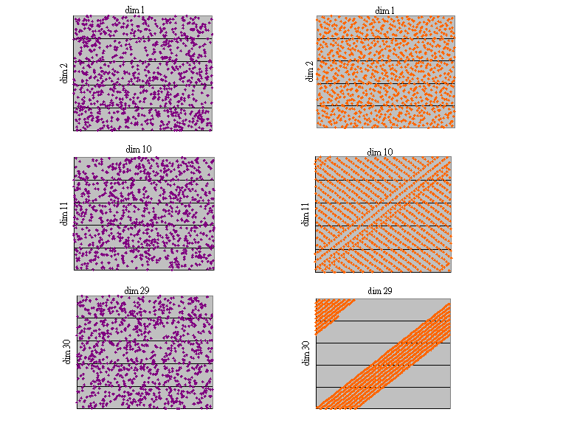
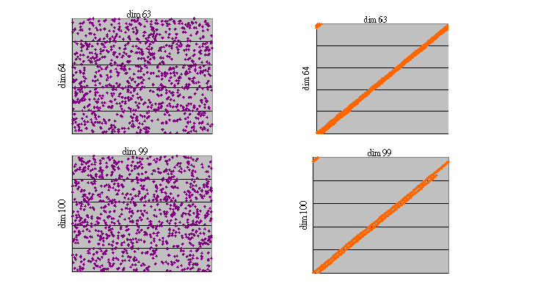

Faure Sobol (regularity breaking initialization)

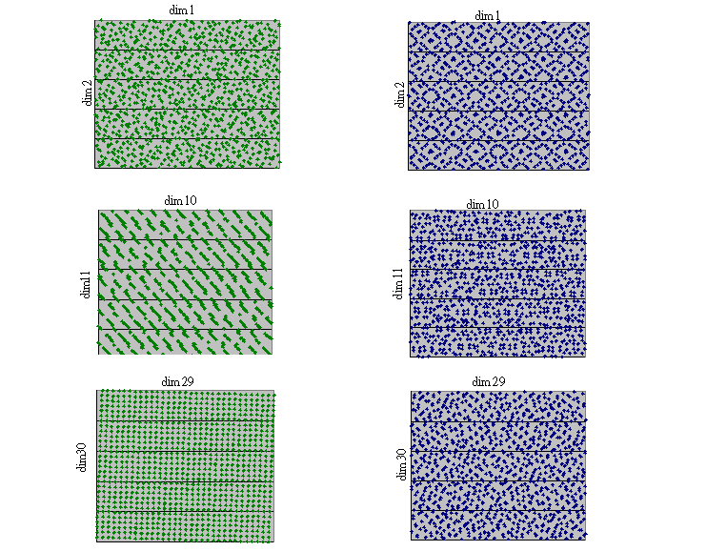
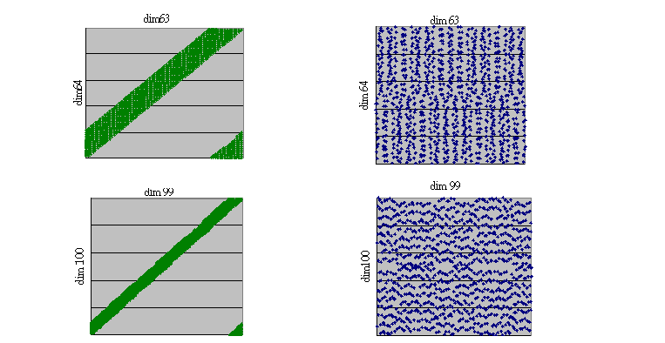

C. Convergence Plots

