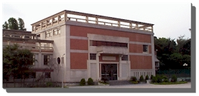


Statistical Analysis of Image Coordinates for Correcting Motion Artifacts
Kirby T. Wu, Hong-Ren Su, Michelle Liou, Cheng-Hung Chuang, and Cheng-Yuan Liou
Institute of Statistical Science, Academia Sinica, Taipei 115, Taiwan
e-mail: stevensu@stat.sinica.edu.tw

Abstract
In fMRI time-series data, it is important to detect and correct, as much as possible, any existing movement-related artifacts which are caused by small head motion during the scanning session. Measuring and correcting motion, if biased, are likely to be ill-posed and even distort the fMRI time-series data. In this study, we propose a statistical method using voxel-wise coordinates which can minimize bias in motion correction. The proposed method relies on a promising segmentation algorithm and a robust statistical movement estimation over segmented time-series data. Additionally, data-refining techniques such as a low-pass wavelet filter can also be applied. These techniques only apply to estimating movement parameters but will not directly modify the resulting time-series data. Resampling is also applied to improve performance. Correlations curves between data in time are used to compare the proposed method with other existing methods for correcting motion artifacts. In the empirical example, the method is applied to a real fMRI data which are known to be contaminated by motion artifacts. The brain activation regions as detected with and without motion correction will be presented.

Brain Image Realignment Method
There are many methods for realignment of brain image[1,2,4] which all involve rigid-body affine transformation. Thus parameter estimation becomes the most important part in these methods. By the asymmetry of the brain, principle components of voxel coordinates can tell us brain orientation. Let the motion correction problem be aligning one brain image to a reference image , where and are three-dimensional with intensity . Let and are three-dimensional coordinate sets of all in-brain voxels in . Based on these voxel coordinates, the origins can be determined as the means of and , denoted as and , respectively. The orientation of both brains can be determined as the principle components of and , denoted as and , respectively. By the use of the centroids and orientations, we can derive the six parameters for rigid-body affine transformation, which is often used in traditional motion correction approach. A more intuitive way is to think and as the same image in different coordinate systems, thus realigning is to make a coordinate-transformation of from -system into - system, which treats and as ordered bases of vector space . The transformation function is then . The transformed brain image is obtained by .

Image Segmentation
In order to obtain and , brain region must be segmented from background and noises. In this approach, a method called slicewise-r-mean-value thresholding is applied. For each single slice in a brain image, threshold is obtained by calculating mean intensity of all voxels on this slice and multiplying this mean by a ratio, a fixed proportion for all slices across brain volumes in the same data set. This threshold is used to collect in-brain voxels. The ratio is determined by maximizing correlation of and . For a large number of brain volumes, k pivot brain images are randomly chosen as. The ratio is then determined by maximizing the summation of correlation between and . For a reasonable size of , the realignment process runs slightly slow but performs well.

Empirical Studies
We examined the proposed method using real experimental data supported by the US National fMRI Data Center. The data were collected in a study investigating the effects of presentation rate on the occipital and parietal regions during word and pseudoword reading (2000-11189). The available data for each subject were 360 functional volumes of MR images scanned in one run with different combinations of experimental conditions. For illustration, we will present the results for Subject 3 in the study. In the simulation study, we randomly select one image volume and randomly generate 99 different 3D orientations. There were totally 100 image volumes; the range of rotation angles was [-7.2°, 7.2°] and location shift in all three directions was [-19mm, 19mm]. In the real data analysis, the 360 image volumes for Subject 3 were all registered to the first volume. Both simulated and real data were aligned by removing motion artifacts using the proposed statistical method and the affine transformation method. To evaluate the performance of these method, correlations between the first image volume and all subsequent image volumes in across scanning time are calculated over raw data, corrected data by the affine transformation method and our proposed method in both real and simulated studied. For real data there are 360 correlation values, and for simulated data there are 100. Higher correlation value usually represents better correction of motion artifacts. Distance squares are also calculated as another criterion, which is defined as . Lower distance square value usually represents better motion correction.

- Experiment

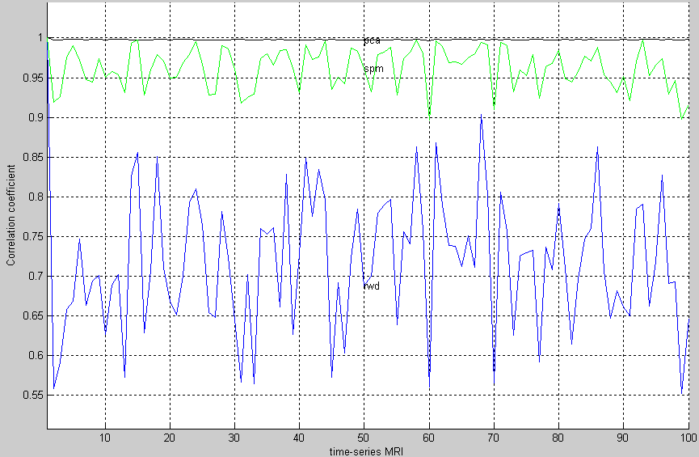 | 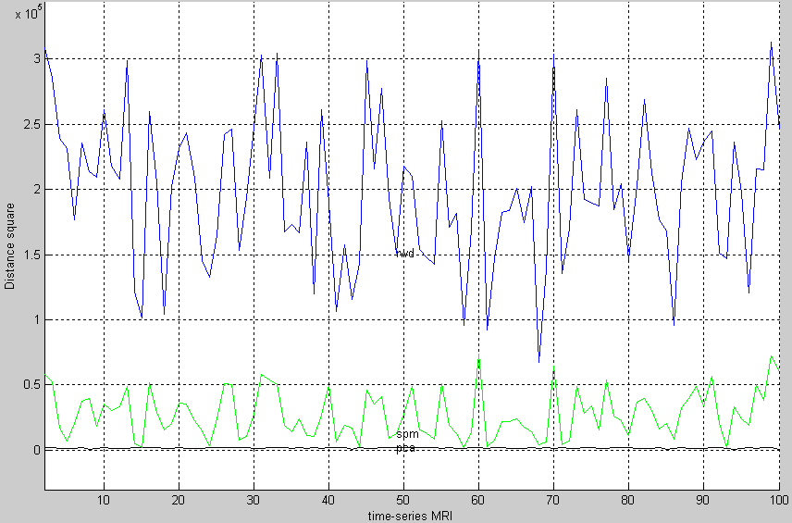 | 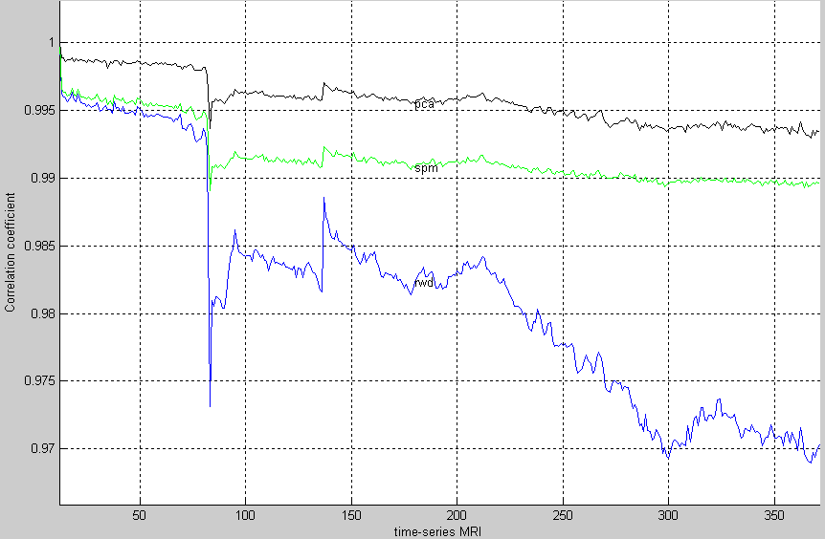 | 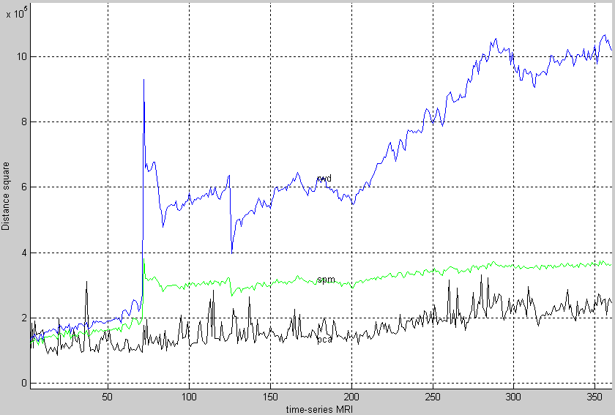
Correlation | Distance square | Correlation | Distance square
Simulation Data |  | Real Data

References:
[1] K. J. Friston, et. al. (1996) Movement-Related Effects in fMRI Time-Series. Magnetic Resonance in Medicine, 35:346-355, 1996.
[2] B. A. Ardekani, et. al. (2001) A quantitative comparison of motion detection algorithms in fMRI. Magnetic Resonance Imaging, 19:959 63, 2001.
[3] L. Freire, et. al. (2002). What is the Best Similarity Measure for Motion Correction in fMRI Time Series? IEEE Transactions on Medical Imaging, 5:470-484, 21, 2002
[4] T. R. Oakes, et. al. (2005) Comparison of fMRI motion correction software tools. NeuroImage, 28:529-543, 2005

