Chapter 6

Synthesis of Associative Memory

Exercise
6.1 (I) Discuss and analyze this Hopfield network:
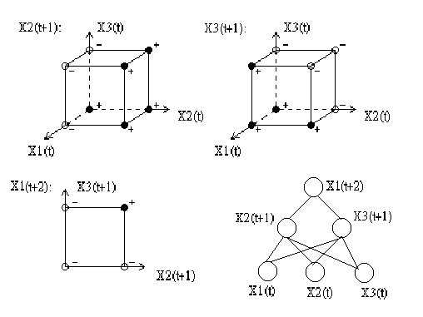

    - Given [x₁(t), x₂(t), x₃(t); t = 0, …., 1000], the functions of {x₂(t+1), x₃(t+1), x₁(t+2)} are unknown. Show how to train this Hopfield network to obtain these functions. Use the modular design in exercise #6.

6.2 There are two types of neurodynamical models (14.18) and (14.19).
- Similar to (14.28), Derive the energy function for (14.19) given it is a Hopfield model satisfying (14.21), (14.22), (14.23), (14.27).
- A: $x_{j}(n+1)=\text{sgn}[\sum_{i=1}^{N}{w_{\text{ji}}x_{i}(n)]}$, j = 1, 2, …, N, (Text page 690, item 3)
B: $v_{j}(n+1)=\sum{w_{\text{ji}}\text{sgn}[v_{i}(n)]}$, j = 1, 2, …, N, (Text page 678, on bottom)
A & B describe a net with binary decision elements, i.e., 2-valued logic. Which one can be constructed so as to give any wanted number k of values at each neuron (k need not be the same for all neurons); they describe therefore as well a net working with some k-valued logic? Show how to construct?

