Chapter 4

The Hidden Tree in Multilayer Network

Exercise
4.1
$X_{1}(t)$
$X_{2}(t+1)$
$X_{2_{1}}(t)$ $Y(t+2)$
$X_{3}(t+1)$
$$X_{\text{31}}(t)$$

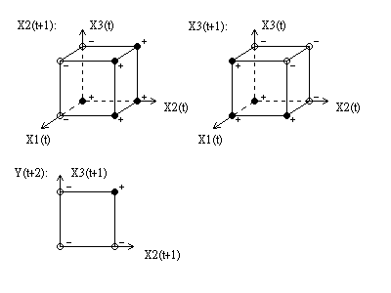
Discuss and analyze the above Elman network on the sequence x₁(t), t = 1, 2, … and y(t), t = 1, 2, 3, …..

