I find that the best way to learn svm is by using the graphical applet svmtoy. It runs under a window within MS Windows, and is self-explanatory. However, several fine points are not initially obvious, and these are given in the following.

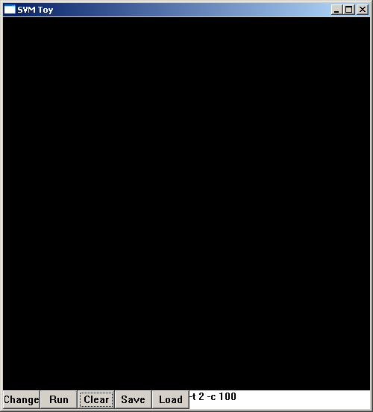

1. First, the window exercises both classification and regression. To do classification, use the mouse to click points inside the window (which will be displayed in the same color). Click “change” before generating more points and this batch will have a different color, signifying that they belong to a different class. Click change again to go back to enter points of the first class, and so on. There are apparently only two-classes allowed – hence, 2-class problems are solved. Press “run” and the classification results are displayed, as shown in the figure below.

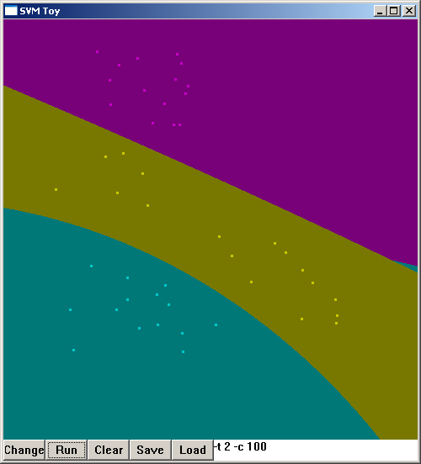

Note the parameters set in the lower-right panel. They define the model used, and are exactly the run-time options (in UNIX style) used when running the various executables on the command line. For the example shown, -t 2 signifies polynomial kernel with default gamma=1/k, where k is the number of attributes in the input (2, for x and y location here) and default degree=3 (i.e., cubic), and default coef0=0. More important, the default application type is –s 0, i.e., C- SVC (support vector classification with cost function).The specification –c 100 corresponds to the cost in the C-SVC algorithm.

Options –s 3 or –s 4 signify the two regression modes available: epsilon-SVR (support vector regression) and nu-SVR, respectively. The kernel options are:

-t 0 -- linear kernel, $K(x_{i},x_{j})=x_{i}^{T}x_{j}$ (no parameter required)
-t 1 -- polynomial of degree d, $K(x_{i}x_{j})=({γx}_{i}^{T}x_{j}+r)^{d}$, parameters -g xx –r xx -d xx
-t 2 -- radial basis function, $K(x_{i},x_{j})=\text{exp}(−γ‖x_{i}−x_{j}‖^{2}),$parameter -g xx
-t 3 -- sigmoid, $K(x_{i},x_{j})=\text{tanh}({γx}_{i}^{T}x_{j}+r)$, parameters -g xx -r xx

Hence, there are quite a variety of algorithms to choose from.

2. Hence, to make the applet do regression, insert the parameter specification –s 3 or –s 4, corresponding to epsilon-SVR or nu-SVR. Suppose we do the former, and clicking in some sample points as illustrated below, then hit run, we would obtain this result:

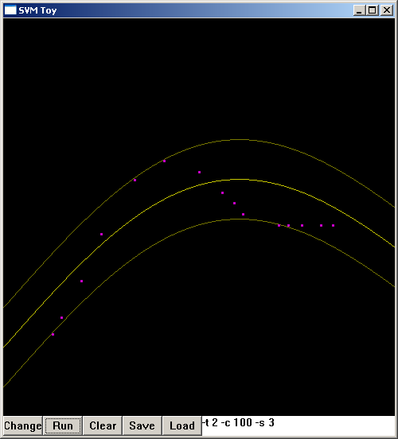

One can experiment with various parameters later. Here, we want to show that hitting “save” will save a sample input file that can be very instructive. We call this file “toy1”, which we reproduce below:

3 1:0.122000 2:0.792000
3 1:0.144000 2:0.750000
3 1:0.194000 2:0.658000
3 1:0.244000 2:0.540000
3 1:0.328000 2:0.404000
3 1:0.402000 2:0.356000
3 1:0.490000 2:0.384000
3 1:0.548000 2:0.436000
3 1:0.578000 2:0.462000
3 1:0.600000 2:0.490000
3 1:0.690000 2:0.518000
3 1:0.714000 2:0.518000
3 1:0.748000 2:0.518000
3 1:0.796000 2:0.518000
3 1:0.826000 2:0.518000

Note that even though we are doing regression, the format is kept as a “classification data file”. Each line corresponds to a data point in the plot, the first entry defines the “class” value, and subsequent entries are in pairs of the form n:float, when n=1, 2, .., gives the attribute number, and float its corresponding value. Here, all points are treated as the same class, which is immaterial. The function definition y=f(x) that one expects, is decomposed into 1:float for the x-value, and 2:float for the y-value – Hence, the data file is in the format of a (pseudo) two-attribute “classification” problem!!!

Less obvious is the fact that the coordinate system used by the applet window: x runs left to right, but y runs from top to bottom. Hence, (0,0) is at the upper left-hand corner of the window.

Note also entries in the data file, except for the class value, are scaled between [0,1]. This is important for proper function of the algorithms.

3. With this experience behind us, we try a more difficult example, which is the sinc function taken from the LSSVM (Suykens et al). First, we need to scale and format the contents to the proper form for use by simtoy, and the results in a file we call 1dtrain1.dat given below:

1 1: 0.000 2: 0.239
1 1: 0.033 2: 0.351
1 1: 0.067 2: 0.342
1 1: 0.100 2: 0.338
1 1: 0.133 2: 0.350
1 1: 0.167 2: 0.375
1 1: 0.200 2: 0.032
1 1: 0.233 2: 0.192
1 1: 0.267 2: 0.059
1 1: 0.300 2: 0.242
1 1: 0.333 2: 0.113
1 1: 0.367 2: 0.437
1 1: 0.400 2: 0.650
1 1: 0.433 2: 0.796
1 1: 0.467 2: 0.939
1 1: 0.500 2: 0.892
1 1: 0.533 2: 0.874
1 1: 0.567 2: 0.768
1 1: 0.600 2: 0.672
1 1: 0.633 2: 0.411
1 1: 0.667 2: 0.396
1 1: 0.700 2: 0.184
1 1: 0.733 2: 0.000
1 1: 0.767 2: 0.118
1 1: 0.800 2: 0.165
1 1: 0.833 2: 0.293
1 1: 0.867 2: 0.331
1 1: 0.900 2: 0.356
1 1: 0.933 2: 0.317
1 1: 0.967 2: 0.329
1 1: 1.000 2: 0.183

(Arbitrary scaling constants are used for convenience, and are not essential to the objective here other than to make the numbers lie between [0,1].)

We then load this file into the window using “load”:
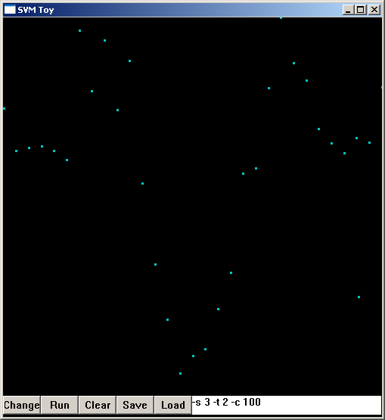

Using the same parameters as in the previous example, hit “run” and get:

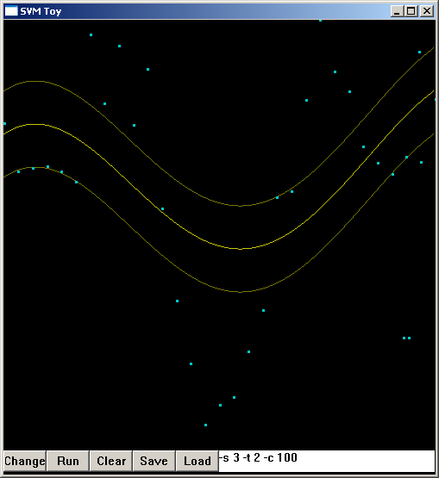

As is obvious, the goodness-of-fit is not good. We remember that for –t 2 (radial basis function), there is a parameter gamma we can adjust. Default value is 1/k, with k=number of attributes=2; so default value is 0.5. The RBF is not very sharp. We try –g 2, a 4-fold increase, and obtain better results:
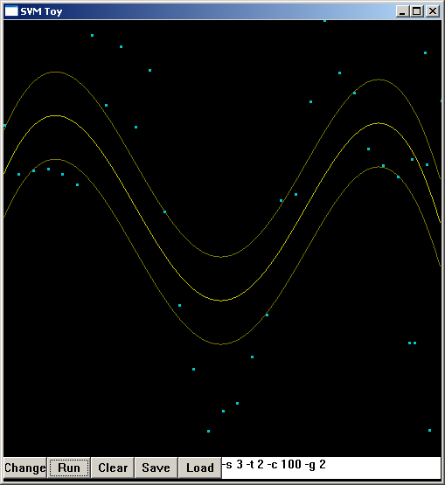

Better and better (more curvy curves) results are obtained as gamma is increased further:
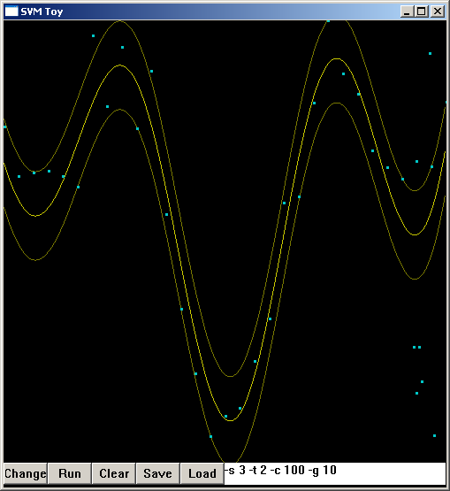

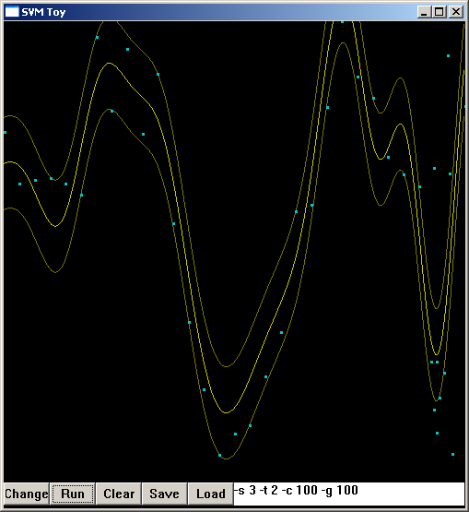

4. Figuring that we should get same results using the command line, we exercise:

svmtrain –s 3 –t 2 –c 100 –g 100 1dtrain1.dat

but get basically blanks.

5. After learning more about file formats used by Libsvm, we understand the mystery. While svmtoy works and generates a data file upon “save”, the file format follows that used for classification, as noted above. However, the runtime command svmtrain, on the other hand, expects a regression file format if we are doing a regression (and not classification). That is, it expects the first entry on each line to be the target value (y value), followed by 1:value, 2:value, etc., for the x value(s). Hence, some rearranging of 1dtrain1.dat obtained from svmtoy is needed if the dataset is to be used on the command line. The proper format for the example is shown below (we name this file 1dtrain1reg.dat)

0.239 1:0.000
0.351 1:0.033
0.342 1:0.067
0.338 1:0.100
0.350 1:0.133
0.375 1:0.167
0.032 1:0.200
0.192 1:0.233
0.059 1:0.267
0.242 1:0.300
0.113 1:0.333
0.437 1:0.367
0.650 1:0.400
0.796 1:0.433
0.939 1:0.467
0.892 1:0.500
0.874 1:0.533
0.768 1:0.567
0.672 1:0.600
0.411 1:0.633
0.396 1:0.667
0.184 1:0.700
0.000 1:0.733
0.118 1:0.767
0.165 1:0.800
0.293 1:0.833
0.331 1:0.867
0.356 1:0.900
0.317 1:0.933
0.329 1:0.967
0.183 1:1.000

and running

svmtrain –s 3 –t 2 –c 100 –g 100 1dtrain1reg.dat

gives these results for the model, 1dtrain1reg.dat.model,

svm_type epsilon_svr
kernel_type rbf
gamma 100
nr_class 2
total_sv 12
rho -0.35336
SV
-0.425130019910836 1:0.1
2.704388008765699 1:0.167
-4.26662737503289 1:0.2
2.089840540817897 1:0.233
-0.6066881726675729 1:0.333
0.325064117144561 1:0.4
0.2697246791048717 1:0.467
0.1299966444627229 1:0.533
0.1100913472723295 1:0.6
0.03992380074787637 1:0.667
-0.3003478770696368 1:0.733
-0.07023569363502197 1:1

indicating that there are 12 support vectors and their respective alpha’s. To see how good the fitting is, we do a test with the same data file with this model file,

svmpredict 1dtrain1reg.dat 1dtrain1reg.dat.model output

The results in output file are compared with the training target below:

Training target | Prediction by model
0.239 1:0.000  0.351 1:0.033  0.342 1:0.067  0.338 1:0.100  0.350 1:0.133  0.375 1:0.167  0.032 1:0.200  0.192 1:0.233  0.059 1:0.267  0.242 1:0.300  0.113 1:0.333  0.437 1:0.367  0.650 1:0.400  0.796 1:0.433  0.939 1:0.467  0.892 1:0.500  0.874 1:0.533  0.768 1:0.567  0.672 1:0.600  0.411 1:0.633  0.396 1:0.667  0.184 1:0.700  0.000 1:0.733  0.118 1:0.767  0.165 1:0.800  0.293 1:0.833  0.331 1:0.867  0.356 1:0.900  0.317 1:0.933  0.329 1:0.967  0.183 1:1.000 | 0.294268  0.306843  0.371781  0.438656  0.415695  0.274738  0.132616  0.0916603  0.128317  0.163794  0.212739  0.346218  0.549711  0.738533  0.838862  0.836945  0.773752  0.680188  0.572165  0.443487  0.296045  0.169514  0.100168  0.107527  0.169285  0.241587  0.292339  0.309243  0.303061  0.289119  0.282884

6. To show that svmtoy is more than a toy, we apply it to a real dataset, the hourly electric power consumption for the month of September, 1989. The parameters shown in the bottom of the window below says that we are doing regression (s = 3) with the radial basis function kernel (t = 2). We keep these two specifications the same, as we vary the other parameters C=10, g (for γ=10) and p (for ε=0.01).

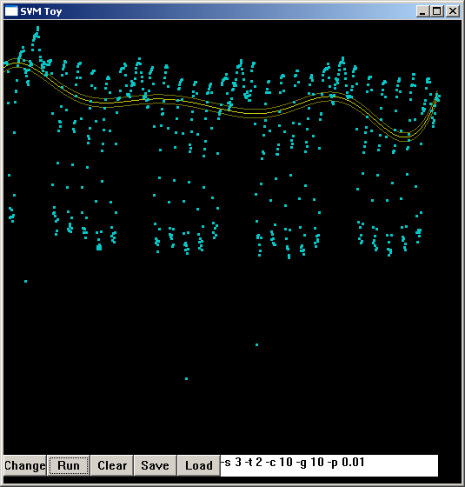

We see that p=0.01 dictates a narrow error band, but C and g are simply not enough.

Increasing g will increase the curvature of the fitting curve as the following figure shows.
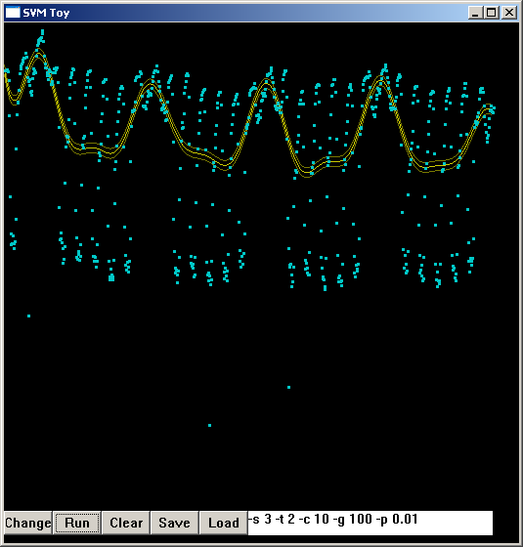

Keep pushing this parameter, we obtain better and better curviness with C=100, C=500, achieving very good results.
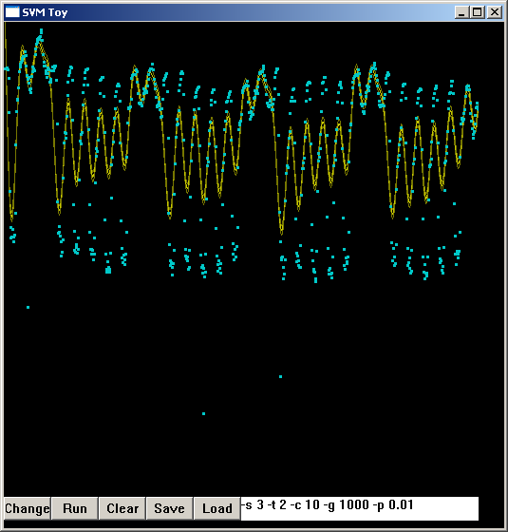

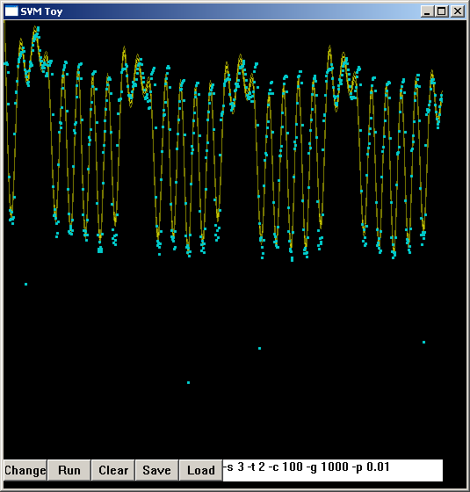

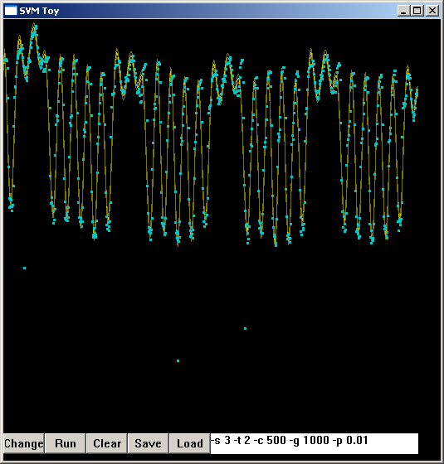

But the run time is long. We then relax the p condition (ε) from 0.01 to 0.1 (default, hence not shown in the following figure). The larger error band is obvious, but run-time is reduced.
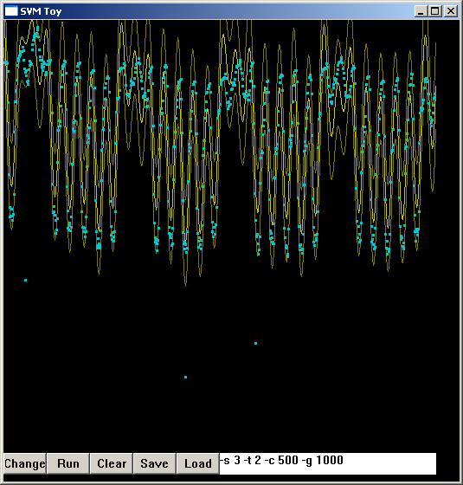

7. We move out of the svmtoy environment (which can handle only x-y datasets) to the command-lines svmtrain and svmpredict, which can handle multidimensional datasets (which is what the dataset is, with six features including day of the week, outside temperature, etc.). The examples below give an idea of the sensitivity of the training results to selected parameter variations. In particular, we notice in multi-dimensional space, we can relax C and γ drastically and yet obtain the same high degree of performance as seen in the x-y case. The combination of C=10 and γ=10 is good enough, although we need to hold on to ε=0.01 to maintain tight tracking.

Parenthetically, with 718 training sets in the data, the machine generates 443 support vectors for ε=0.01 (Case d), but requires only 37 support vectors when ε is relaxed to 0.1 (Case c).

(a) | (c)
(b) | (d)

